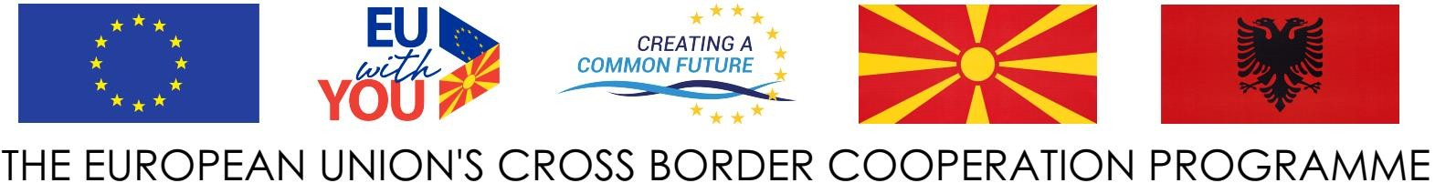



MUNICIPALITY OF POGRADEC

**LETTER OF EXPRESSION OF INTEREST**

Dear All,

We would like to express our interest to participate in the **“STRUGA & POGRADEC FOR PROMOTING TOURISM AND CULTURAL HERITAGE - COOLTOUR”**, project funded by the Cross-border Programme the Republic of North Macedonia - Republic of Albania under the Instrument of Pre-Accession Assistance (IPA II) allocations for 2018 – 2020 (Reference: EuropeAid/170339/DD/ACT/MK).

This letter is a statement of engagement and confirmation that the (Name of Participants) will participate in the activities under the **“COOLTOUR”** project.

The Expert (name) _______ confirms that will support and collaborate with Municipality of Pogradec staff in order to deliver the expected outputs of the project during implementation stage, as well as give full support in terms the of staff to participate and dedicated to the concerned and involved activities in the realization of the project.

Sincerely

_________________

( name & signature )

