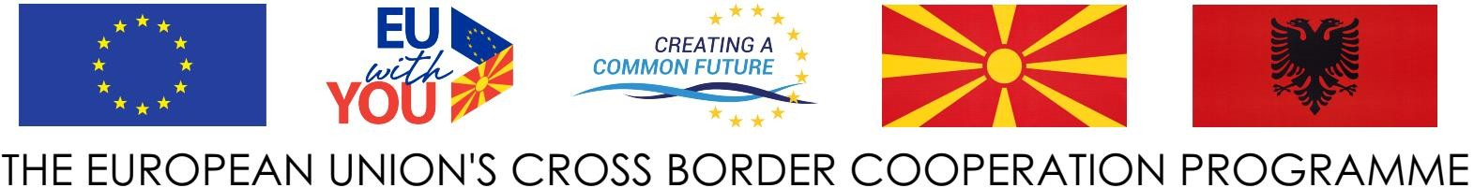



**MUNICIPALITY OF POGRADEC**

**CALL OFEXPRESSION OFINTEREST FOR PARTICIPATION ON “STRUGA & POGRADEC FOR PROMOTING TOURISM AND CULTURAL HERITAGE - COOLTOUR”, PROJECT FUNDED BY THE CROSS-BORDER PROGRAMME THE REPUBLIC OF NORTH MACEDONIA - REPUBLIC OF ALBANIA UNDER THE INSTRUMENT OF PRE-ACCESSION ASSISTANCE (IPA II) ALLOCATIONS FOR 2018 – 2020 (REFERENCE: EUROPEAID/170339/DD/ACT/MK).**

Municipality of Pogradec is pleased to announce opening the Call for participation on “STRUGA & POGRADEC FOR PROMOTING TOURISM AND CULTURAL HERITAGE - COOLTOUR”, project funded by the CROSS-BORDER PROGRAMME THE REPUBLIC OF NORTH MACEDONIA - REPUBLIC OF ALBANIA UNDER THE INSTRUMENT OF PRE-ACCESSION ASSISTANCE (IPA II) ALLOCATIONS FOR 2018 – 2020 (REFERENCE: EUROPEAID/170339/DD/ACT/MK).

**Overall Objective** of this project is to stimulate a balanced, inclusive and sustainable socio-economic development in the cross-border area of Ohrid Lake.

**Specific Objective** is to develop the potential of tourism by promoting cultural heritage and values in both Municipalities of Struga and Pogradec. It is expected that the action will increase the business opportunities for local service providers and operators in the field of tourism and furthered mutual cooperation, understanding and respect of cultural heritage and values.

**The result of COOLTOUR Project** is conceived to promote an effective mutual cross-border cooperation, understanding and respect of cultural heritage between the two sites of Ohrid Lake, and fostering business opportunities for local service providers and operators in  
the field of tourism.



**______________________________________________________________________________**



**MUNICIPALITY OF POGRADEC**

**Relevant experts {Project officer} will be engaged:**

Project Officer will be in charge to support PM and staff of Municipality of Pogradec in the implementation of CB activities on Albanian side. She/He will be recruited as external expert following a public call launched by Municipality of Pogradec, for the sole purpose of implementation of this project resulting from the grant award.

**Selection criteria:**

***a.)Professional capacity of the tenderer***

Post Graduate Degree in at least one of the following fields: law,tourism, economics, marketing, management, business administration.

Minimum of 5 years’ in the following fields: law,tourism, economics, marketing, management, business administration.

***b.) Technical capacity of tenderer***

To prove experience in the field of studies, law, management, tourism

To have at least one experience with EU projects. That will be considered as asset.

To have good knowledge of English language.

***c.) Other technical specifications***

Project work duration: 2 January 2022 - 31 December 2024 (3 years)

Salary ( 40 % part time) : 11,232 EUR total

As results of this activity, it is expected to apply with good quality of proposals under this call, where the main beneficiaries are the Local and regional authorities and communities, assuring the coherence and complementarity with other projects with similar focus of activities. All eligible potential applicants should express their interest by sending CV ,Diploma, Certificate, hand delivery or by post until **21 of January 2022** working hours 08:00 Am to 16.00 Pm at the following address: **Municipality of Pogradec ,Bulevardi “Reshit Çollaku” Lagja nr.2**

