PROJECT EXTRO-CULT

“Εnhancement, Extroversion on Culture, Folkloric and Gastronomic Tourism”

Municipality of Pogradec, in the framework of implementing the project projektit Extro-Cult financed from the Interreg IPA CBC Greece-Albania 2014-2020 organized:
“Final Conference in Pogradec”
The conference was organized by the Municipality of Pogradec, as a beneficiary of the project on 14.12.2021 in the Conference Hall, Hotel Enkelana.
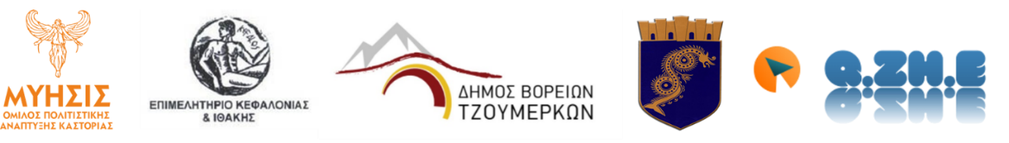
ΘΕΑΤΡΟ ΤΣΗ
ΖΑΚΥΝΘΟΣ
ΕΠΑΓΓΕΛΜΑΤΙΚΗ ΣΚΗΝΗ

