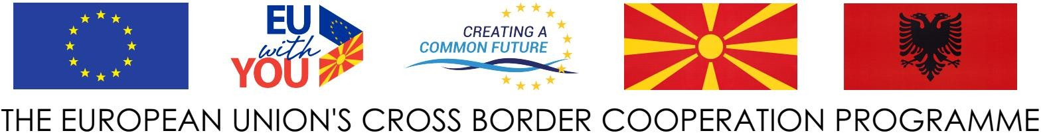



MUNICIPALITY OF POGRADEC

**LETTER OF EXPRESSION OF INTEREST**

Dear All,

We would like to express our interest to participate in the **“STRUGA & POGRADEC FOR PROMOTING TOURISM AND CULTURAL HERITAGE - COOLTOUR”**, project funded by the Cross-border Programme the Republic of North Macedonia - Republic of Albania under the Instrument of Pre-Accession Assistance (IPA II) allocations for 2018 – 2020 (Reference: EuropeAid/170339/DD/ACT/MK).

This letter is a statement of engagement and confirmation that the **(Name of the legal person),** will participate in the activity quoted under the **“COOLTOUR”** project.

The (**Name of legal entity)** confirm that will support and collaborate with the Municipality of Pogradec during the process of project stages.

Sincerely

_________________

( name & signature )

